TASK30:

OUTPUT:
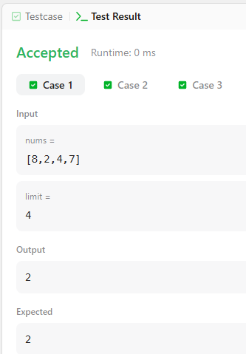

LONGEST CONTINUOUS SUBARRAY WITH ABSOLUTE DIFF LESS THAN or EQUAL TO LIMIT
PROGRAM:
class Solution {
public int longestSubarray(int[] nums, int limit) {
Deque<Integer> maxDeque = new LinkedList<>();
Deque<Integer> minDeque = new LinkedList<>();
int left = 0;
int maxLength = 0;

for (int right = 0; right < nums.length; right++) {
while (!maxDeque.isEmpty() && maxDeque.peekLast() < nums[right]) {
maxDeque.pollLast();
}
maxDeque.addLast(nums[right]);

while (!minDeque.isEmpty() && minDeque.peekLast() > nums[right]) {
minDeque.pollLast();
}
minDeque.addLast(nums[right]);

while (maxDeque.peekFirst() - minDeque.peekFirst() > limit) {
if (maxDeque.peekFirst() == nums[left]) {
maxDeque.pollFirst();
}
if (minDeque.peekFirst() == nums[left]) {
minDeque.pollFirst();
}
left++;
}

maxLength = Math.max(maxLength, right - left + 1);
}

return maxLength;
}
}

